Output of opening the requested images in the browser.

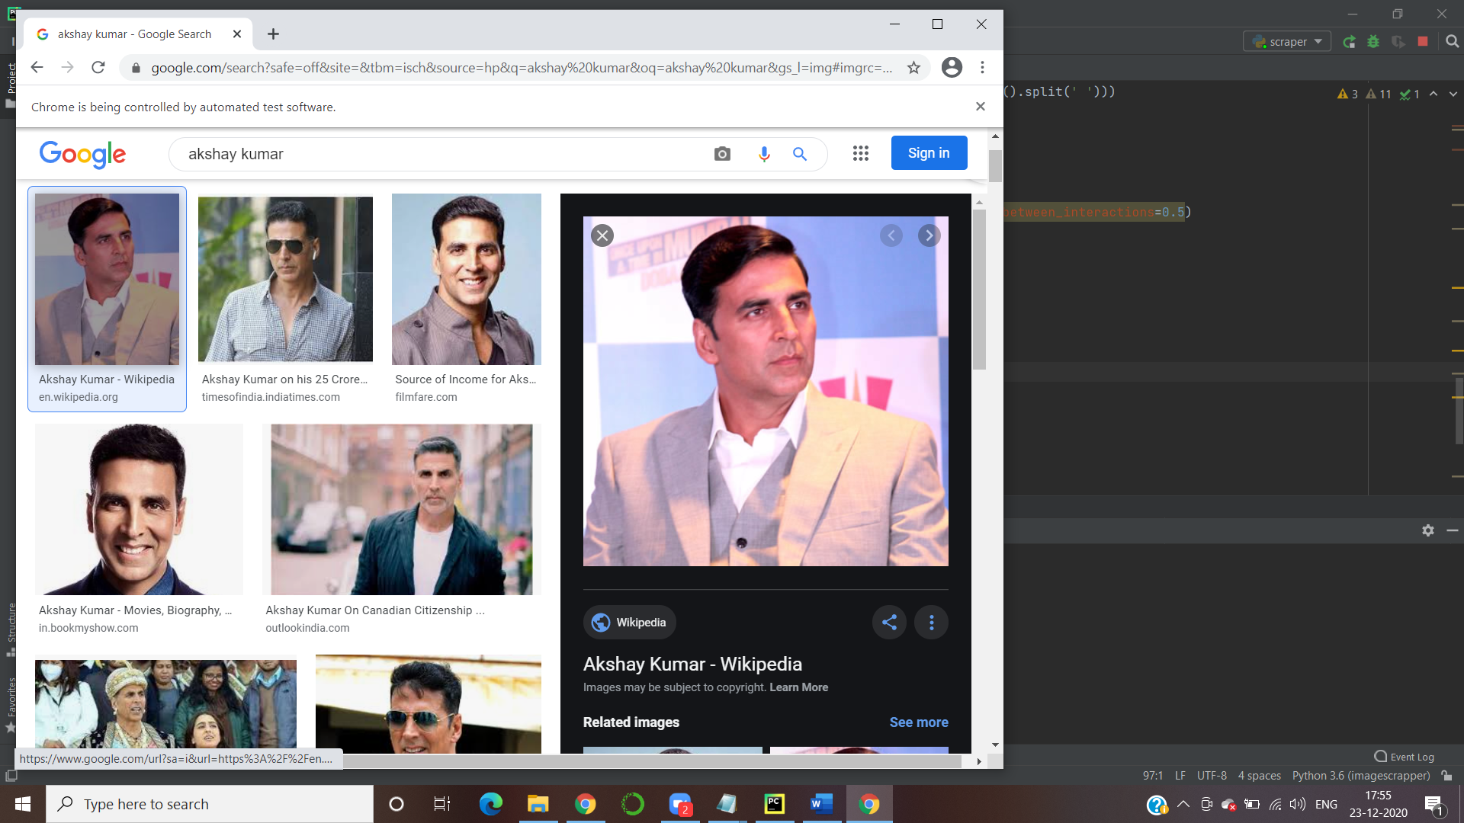

This is the output of Image Scrapper. I have run this for different keywords on windows platform.

